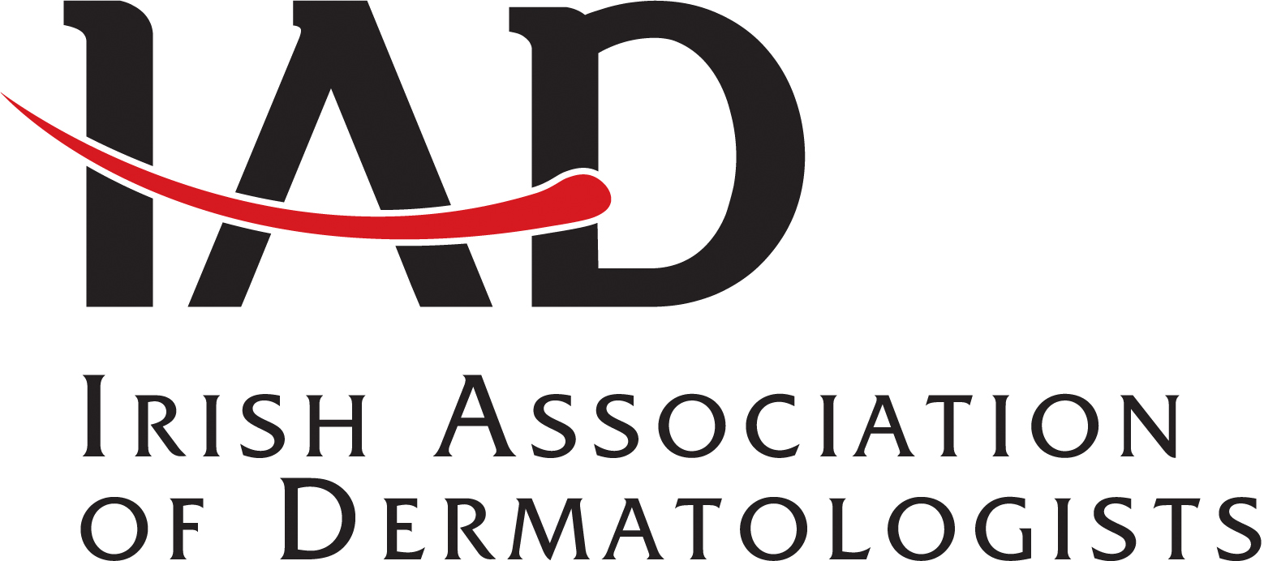

**Symposium sponsored by La Roche-Posay and CeraVe**

Irish Association of Dermatologists --- Autumn meeting

10th of October at the Fairways Hotel, Dundalk

Confirmed Faculty

**Professor Mike Cork**  
*Head of Sheffield Dermatology Research in the Department of Infection, Immunity & Cardiovascular Disease at the University of Sheffield Medical School; and Honorary Consultant Dermatologist to both Sheffield Children´s Hospital NHS Foundation Trust and to Sheffield Teaching Hospitals NHS Foundation Trust*

**Dr Hiva Fassihi**

Consultant Dermatologist and Head of Photodermatology Unit at St John’s Institute of Dermatology, Guy’s and St Thomas’ NHS Foundation Trust, London. Clinical Lead for the UK National Xeroderma Pigmentosum (XP) Service. As an Honorary Reader at King's College London, she is involved in translational research in Xeroderma Pigmentosum and other disorders of abnormal DNA repair and has collaborated with international groups.

**Chair -Dr Suzanne Clements ---** Consultant Dermatologist, Belfast City Hospital

**Programme**

**9.30am** Registration and Breakfast

**10.30am**

Welcome & Opening remarks

*Dr Suzanne Clements*

**10:45am**

Cases from the Photo Dermatology Clinic

*Dr Hiva Fassihi*

**11.30am**

A Deeper Look at Restoring the Skin Barrer: Enhancing the Barrier’s Structure and Function for Patients with Dry, Eczema-Prone Skin *Professor Mike Cork*